|  |  |
| --- | --- |
|  | |
| DATAWAYS-COA-  **ALL-38-Cargo Flow Segmentation Back-end Logic-Main boundary (Long Leg) port definition (Part I)**  **ALL-611: CF Segmentation Back End Logic - Main boundary (Long Leg) port definition (Part II)**  **ALL-612: Cargo Flow Segmentation Back End Logic - Sub-boundary port definition (Part I)**  **ALL-613: CF Segmentation Back End Logic - Sub-boundary port definition (Part II)**  **ALL-614: Cargo Flow Segmentation Back End Logic - Trigger Rule**  **ALL-615: Cargo Flow Segmentation Back End Logic - Boundary template version ID definition**  Functional Specification | |
| Department: CMA CGM Commercial and Operational Allocation  Project: *DATAWAYS*  JIRA ID: *ALL-38*  Author(s): Infosys | |
| Doc Reference:  Date:  Version:  Status: | DATAWAYS-COA-LT-FND-ALL-38-CFS Back-end Logic: Boundary Port Determination  10-Apr-2024 1.1 Approved |
| Classification: **Internal** | |

REVISIONS

|  |  |  |  |
| --- | --- | --- | --- |
| **Version** | **Date** | **Author** | **Subject** |
| 0.1 | 10-Apr-2024 | Savli | Document creation |
| 1.0 | 11-Apr-2024 | Savli | Document Approved |
| 1.1 | 19-Apr-2024 | Savli | US Split |
| 1.2 | 29-May-2024 | Savli | Few points added in ALL-615 for versioning |

**REVIEWS**

|  |  |  |  |  |  |
| --- | --- | --- | --- | --- | --- |
| **Name** | **Title** | **Version** | **Date** | **Company** | **Signature** |
| Prabhu SESHADRI | IT Domain Lead | 0.1 | 11-Apr-2024 | CMA CGM | Prabhu SESHADRI |
| HIENG Laurent | Product Owner | 0.1 | 11-Apr-2024 | CMA CGM | HIENG Laurent |

APPROVALS

|  |  |  |  |  |  |
| --- | --- | --- | --- | --- | --- |
| **Name** | **Title** | **Version** | **Date** | **Company** | **Signature** |
| HOELLARD Damien | Lead Product Owner | 1.0 | 11-Apr-2024 | CMA CGM | HOELLARD Damien |

DISTRIBUTION LIST

|  |  |  |  |  |
| --- | --- | --- | --- | --- |
| **Name** | **Title** | **Company** | **To** | **Cc** |
| HOELLARD Damien | Lead Product Owner | CMA CGM | X |  |
| HIENG Laurent | Product Owner | CMA CGM | X |  |
| Prabhu SESHADRI | IT Domain Lead | CMA CGM |  | X |
| Veronique JOUSSELLIN | IT Domain Owner | CMA CGM |  | X |
| Julien D’ELIA | Enterprise Architect | CMA CGM |  | X |
| Youssef ATIK | Solution Architect | CMA CGM |  | X |
| Rudy MACARONUS | Chief Architect | CMA CGM |  | X |
| Victor BONY | Project Manager | CMA CGM |  | X |
| Ganesh IYER | Proxy Product Owner | Infosys |  | X |
| Ellina GALCHENKO | Product SME | Infosys |  | X |
| Irfan KHAN | Product SME | Infosys |  | X |
| Savli TAPRE | Product SME | Infosys |  | X |
| Aishwarya RAJAN | UX Lead | Infosys |  | X |
| Tameshwar SAHU | Solution Architect | Infosys |  | X |
| Tapas SARKAR | Solution Architect | Infosys |  | X |
| Bhuvanesh Sankarbabu | Scrum Master | Infosys |  | X |
| Sinchu PANICKER | PMO | Infosys |  | X |

CONTENTS

1 - Requirements 5

1.1 Document references 5

1.2 New or Modified Objects 5

1.3 Acronyms & Glossary 6

2 - Detailed Design 8

2.1 Business Context and Scope 8

2.2 Business Constraints or Assumptions 8

2.3 Functional Solution Risk 8

2.4 Requirement Details 8

2.5 Process Flow and Domain Entities 9

2.6 UI / UX Design 10

2.7 Validation and Rules 10

2.8 Setups and configurations 11

2.9 Processing definition 11

2.10 Functional Test Cases 16

3 - Technical Details (Optional) 19

# 

# - Requirements

|  |  |
| --- | --- |
| **Requirement ID** | **User Story/Requirement Description** |
| [ALL-38](https://cmacgm.atlassian.net/browse/ALL-38?jql=project%20%3D%20%22ALL%22%20ORDER%20BY%20created%20DESC) | Cargo Flow Segmentation Back End Logic: Boundary Port determination |
| [ALL-611](https://cmacgm.atlassian.net/browse/ALL-611) | CF Segmentation Back End Logic - Main boundary (Long Leg) port definition (Part II) |
| [ALL-612](https://cmacgm.atlassian.net/browse/ALL-612) | Cargo Flow Segmentation Back End Logic - Sub-boundary port definition (Part I) |
| [ALL-613](https://cmacgm.atlassian.net/browse/ALL-613) | CF Segmentation Back End Logic - Sub-boundary port definition (Part II) |
| [ALL-614](https://cmacgm.atlassian.net/browse/ALL-614) | Cargo Flow Segmentation Back End Logic - Trigger Rule |
| [ALL-615](https://cmacgm.atlassian.net/browse/ALL-615) | Cargo Flow Segmentation Back End Logic - Boundary template version ID definition |

## 

### Document references

|  |  |  |  |  |
| --- | --- | --- | --- | --- |
| **Reference** | **Description** | **Version** | **Date** | **Author** |
| [ALL-217](https://cmacgm.atlassian.net/browse/ALL-217) | Cargo Flow Segmentation (Screen): Filter Bar | Available in JIRA | NA | Savli Tapre |
| [ALL-216](https://cmacgm.atlassian.net/browse/ALL-216?jql=project%20%3D%20%22ALL%22%20ORDER%20BY%20created%20DESC) | Cargo Flow Segmentation (Screen): CVN Search Results | Available in JIRA | NA | Irfan Khan |
| [ALL-215](https://cmacgm.atlassian.net/browse/ALL-215?jql=project%20%3D%20%22ALL%22%20ORDER%20BY%20created%20DESC) | CF Segmentation Back End Logic – Bound and CVN determination | Available in JIRA | NA | Savli Tapre |
| [ALL-218](https://cmacgm.atlassian.net/browse/ALL-218?jql=project%20%3D%20%22ALL%22%20ORDER%20BY%20created%20DESC) | Cargo Flow Segmentation (Screen): Port Call Sequence (Columns from Schedule) | Available in JIRA | NA | Savli Tapre |
| [ALL-247](https://cmacgm.atlassian.net/browse/ALL-247) | Cargo Flow Segmentation (Screen): Port Call Sequence (Bound and Boundary Type) | Available in JIRA | NA | Savli Tapre |
| [ALL-248](https://cmacgm.atlassian.net/browse/ALL-248) | Cargo Flow Segmentation (Screen): Port Call Sequence (additional functionalities) | Available in JIRA | NA | Savli Tapre |
| [ALL-214](https://cmacgm.atlassian.net/browse/ALL-214?jql=project%20%3D%20%22ALL%22%20ORDER%20BY%20created%20DESC) | CF Segmentation Back End Logic – Leg Definition determination | Available in JIRA | NA | Irfan Khan |
| [ALL-43](https://cmacgm.atlassian.net/browse/ALL-43?jql=project%20%3D%20%22ALL%22%20ORDER%20BY%20created%20DESC) | Cargo Flow Segmentation (Screen) - Leg Definition tables | Available in JIRA | NA | Irfan Khan |
| [ALL-164](https://cmacgm.atlassian.net/browse/ALL-164?jql=project%20%3D%20%22ALL%22%20ORDER%20BY%20created%20DESC) | Mass reset segmentation: Cargo Flow Segmentation Logic | Available in JIRA | NA | Irfan Khan |
| [ALL-139](https://cmacgm.atlassian.net/browse/ALL-139?jql=project%20%3D%20%22ALL%22%20ORDER%20BY%20created%20DESC) | Role and authorization | Available in JIRA | NA | Ellina Galchenko |

### 

### New or Modified Objects

|  |  |
| --- | --- |
| **Components involved and purpose (Part of technical Document)** | |
| Screen ID xxx |  |
| API Name xxx |  |
|  |  |
|  |  |
|  |  |
|  |  |

### Acronyms & Glossary

|  |  |  |
| --- | --- | --- |
| **Term** | **Acronym** | **Definition** |
| Cargo Flow Bounds | Cargo Flow Bounds | A schedule bound is a segregation of a technical voyage into separate blocks that indicate the direction of the vessel sailing.  Schedule bounds have a 1:1 relation with a Commercial Voyage Number (CVN).  Schedule bound will be displayed as EB, WB, NB, SB and RT.  Cargo Flow bound in CFS screen is not the same as schedule bound as it gets changed as per the CFS logic. When there is no Boundary Template applied or Manual adjustment made to CFS then the CFS rule (last port of the CVN will be automatically marked as Main Boundary (Long Leg) by the system) will get applied and at that point the Schedule Bound and Cargo Flow Bound will be the same. |
| Service | Service | Service (Line) is a regular rotation operated by a group of vessels for a dedicated geographical corridor. |
| Service ID | Service ID | Service ID is a unique identifier associated with the Service. |
| CVN | CVN | * Commercial voyage numbers (CVNs) are used in addition to voyage numbers to identify a voyage on the bound level. CVNs contain information about the voyage, which is useful for business purposes (for example, from the CVN you can tell who is the carrier for the voyage). * CVNs are composed of nine alphanumeric characters and follow a fixed format that you must configure for each line. You assign CVNs when you are generating voyages and you also have the option to edit the CVNs for voyages. Each character in a CVN represents a piece of information about the voyage. The system uses statuses to track the life cycle of CVNs. * Schedule CVN and back-end CVN are different. |
| Vessel Name | Vessel Name | Name of the freight-carrying ship |
| Cargo Flow Segmentation | CFS | Cargo flow segmentation is needed to assign boundaries to some ports, this will determine the leg definition and cargo flow bounds |
| Sequence | Sequence | The sequence will come from the Schedule and will contain numbers like 1, 2, 3, 4 etc. |
| Port ID | Port ID | It is the identification code given to every port. It will come from the schedule. |
| Terminal ID | Terminal ID | A terminal is an area or location which serves as a pathway for loading and/or unloading cargo. It is the identification code given to every terminal. |
| Boundary Type | Boundary Type | It will either be blank for few ports or can have values like Sub-Boundary and Main Boundary (Long Leg) |
| Schedule Week (At Berth) | Schedule Week (At Berth) | Schedule Week (At Berth) of a particular port is calculated by the system using the Berthing date (present in the schedule) of that port because in C-Voyage (scheduling system) there is no schedule week but only Berth date. |
| Schedule Date (At Berth) | Schedule Date (At Berth) | Schedule date will come from the Schedule which corresponds to Berth Date. It is the date the vessel is scheduled to reach that particular port. |
| Proforma Week (At Berth) | Proforma Week (At Berth) | Proforma Week (At Berth) of a particular port is calculated by the system using the proforma date (present in the C-Voyage (schedule system) as Proforma Berth Date) |
| Proforma Date (At Berth) | Proforma Date (At Berth) | Proforma date corresponds to the Proforma Berth date (at berth) in C-Voyage (schedule system). |
| Previous Voyage Rotation | Previous Voyage Rotation | It will be the technical/executable voyage rotation which will be displayed in the first position of port call sequence table. It will be the chained voyage rotation from the schedule just before the voyage rotation in focus in CFS. |
| Voyage Rotation | Voyage Rotation | It will be the technical/executable voyage rotation which will be displayed in the second position of port call sequence table. It will be as per the selected CVN in the filter bar and will be in focus. |
| Next Voyage Rotation | Next Voyage Rotation | It will be the technical/executable voyage rotation which will be displayed in the third position of port call sequence table. It will be the chained voyage rotation from the schedule immediately after the voyage rotation in focus in CFS. |
| Chaining of Voyage | Chaining of Voyage | For the voyage on focus, the vessel deployed for this voyage is connected to a previous voyage and a next voyage. In such a case the previous and next voyages are the chained voyages of the current vessel /voyage combination. |

# - Detailed Design

### Business Context and Scope

This document covers the back-end logic for determining the boundaries required for Cargo Flow Segmentation. Boundaries will play a critical role in determining the cargo flow bound, back-end CVN, generation of CVN Search Result table, port call sequence table and Leg Definition tables.

**Note:** There are separate user stories covering the CFS back-end logic for bound and CVN determination, back-end logic for leg definition determination and cargo flow segmentation (Screen) for filter bar, CVN search results, port call sequence, leg definition table and mass reset segmentation.

### Business Constraints or Assumptions

* The data in boundary type column will need integration with the boundary template (there are other sources as well to get data in this field for the technical/executable voyage rotation in focus).
* Cargo Flow Segmentation feature will be available in the Cargo Flow Portal for all the Cargo Flow users.
* All the Cargo Flow Users will be able to access the Cargo Flow Segmentation Screen which will display the port call sequence table.

**Note:** Roles and authorization will be covered in a separate user story ALL-139

### Functional Solution Risk

N/A

### Requirement Details

It includes the back-end logic for determining the boundary port(s) in every technical/executable voyage rotation. There are 7 rules to determine the main boundary (long leg), 3 rules to determine the sub-boundary, trigger rules and boundary template version ID definition covered in this document. With the help of these rules, the system should map the boundaries and/or allow manual adjustments in the boundary column after which the cargo flow bound and back-end CVN will be defined.

### Process Flow and Domain Entities

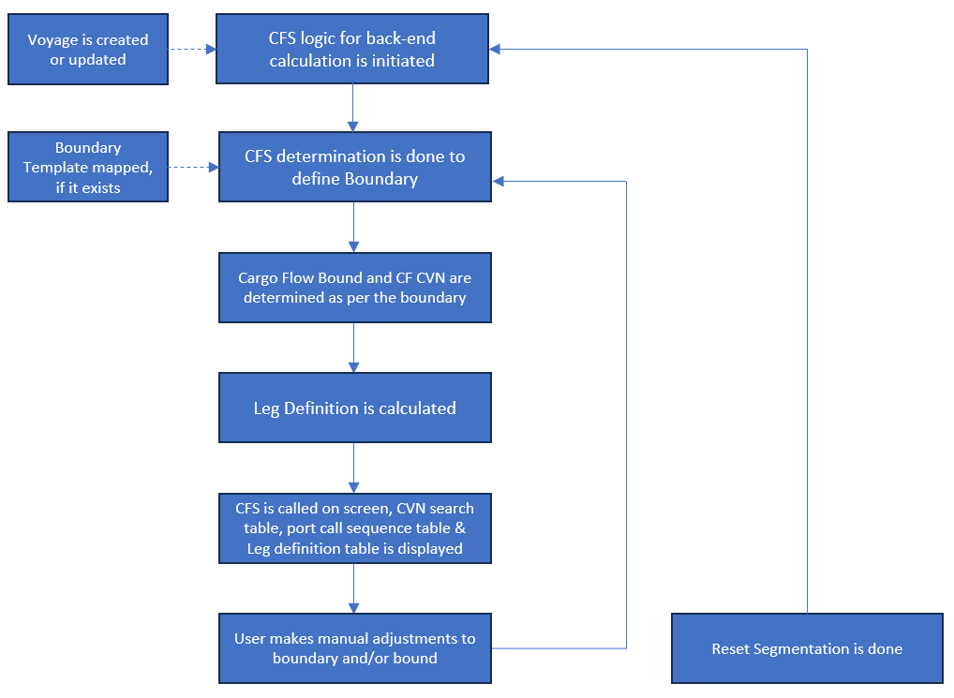

### UI / UX Design

***(Just for Reference to visualize the output of the Back-end Logic of Boundary Port Determination.)***

* In case of end of schedule and there are no further technical/executable voyage, the main boundary (Long Leg) will be applied by the system to the last port of the last CVN of the last technical voyage as per the Schedule, even if there is an active boundary template.

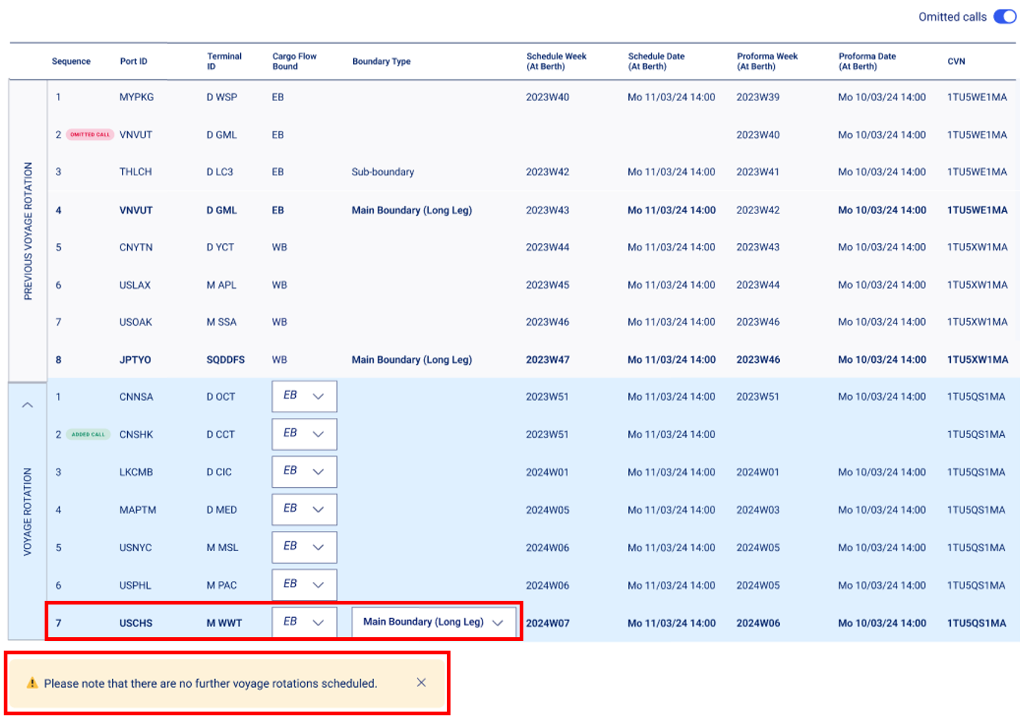

.

### Validation and Rules

Below are the **detail definitions** for **attributes**, button and error message in **Cargo Flow Segmentation Backend Logic Bound and CVN Determination.**

|  |  |  |  |  |  |  |  |
| --- | --- | --- | --- | --- | --- | --- | --- |
| **SR** | **Label** | **Description** | **F** | **A** | **D** | **List** | **Rules** |
|  |  |  |  |  |  |  |  |
|  |  |  |  |  |  |  |  |
|  |  |  |  |  |  |  |  |
|  |  |  |  |  |  |  |  |
|  |  |  |  |  |  |  |  |
|  |  |  |  |  |  |  |  |
|  |  |  |  |  |  |  |  |
|  |  |  |  |  |  |  |  |

Legend

|  |  |  |  |  |  |  |  |  |
| --- | --- | --- | --- | --- | --- | --- | --- | --- |
| **Format** | CB | Check Box | **Attribute** | M | Mandatory | **Display** | D | Field disabled |
| FA | Field alpha | O | Optional | E | Field Enabled |
| FN | Field numeric |  |  | R | Read Only |
| LOV | List of Value |  |  | H | Hidden |
| DA | Date |  |  |  |  |
| BT | Button |  |  |  |  |
| DT | Date Time |  |  |  |  |

### Setups and configurations

* User authorization will be handled in a separate user story ALL-139 (Roles and authorization)
* The data in boundary type column will need integration with the boundary template (there are other sources as well to get data in this field for the technical/executable voyage rotation in focus).
* All other parts related to the CFS per voyage will be covered in ALL-216, ALL-215, ALL-217, ALL-218, ALL-214, ALL-43, ALL-164, ALL-247, ALL-248, ALL-611, ALL-612, ALL-613, ALL-614 and ALL-615.

### Processing definition

Following business rules must be implemented:

|  |  |
| --- | --- |
| **ALL-38- CFS Back-end Logic: Main boundary (Long Leg) port definition (Part I)** | |
| **Main Boundary (Long Leg) port definition** | |
| **BR01** | **Boundary definition for main boundary (long leg)**   * Boundary type will be initially the output of the CFS logic which will depend on  1. Boundary Template 2. CFS rule: If no boundary template exists for the voyage (CVN), apply as main boundary (Long Leg) the last port of the CVN, as per the port call sequence. 3. End of schedule Exception: Main boundary (Long Leg) should always be applied to the last port of the last CVN of the last technical voyage as per the Schedule, even if there is an active boundary template.  * Once the CFS is displayed on the screen (will be covered in ALL-247)  1. The Cargo Flow user can do manual adjustment in the Boundary Type column after which the Cargo Flow Bound should change automatically after each last main boundary (Long Leg) port (even if adjusted manually) within the Schedule CVN to the next bound as per the schedule. |
| **BR02** | **Rule 1:**  **If main boundary (Long Leg)(s) is/are defined in the boundary template, apply it as main boundary (Long Leg)(s) at voyage (CVN).**  **Example of scenarios:**   * If a port in a boundary template is set as main boundary for a bound, then it should show that port as main boundary (Long Leg) port for that bound in CFS screen. * Main boundary (Long Leg) port should not be changed in case of omitting a port that is not main boundary (Long Leg) port. * Main boundary (Long Leg) port should not be changed in case of swapping terminals within the same port, even if it is main boundary (Long Leg) port. * Main boundary (Long Leg) port defined in the boundary template should not be changed in case of adding a call before or after main boundary (Long Leg) port. * The main boundary (Long Leg) port is set in the boundary template for a bound. However, this port was not present in voyage in the initial schedule and is ultimately added as per schedule changes. Then, this port should become main boundary (Long Leg) port as per the boundary template. (If there is no main or alternative boundary in the boundary template then the last port of that schedule CVN will become the default main boundary (long leg). In this case, when the port which is the main boundary (long leg) is added in the schedule then this default boundary will be replaced with the added port main boundary (long leg)). * If a voyage had been deleted and later restored, main boundary (Long Leg) port(s) should also be restored as per the boundary template. * Main boundary (Long Leg) port should be as per the boundary template setup, in case of phase in / phase out of vessels across different services. * Main boundary (Long Leg) port should not be changed in case of port swap within the bound. * **Example:**   If the port call sequence is A-B-**C**-D-E-F-G for EB but port C which is main boundary is swapped with Port F then port C will continue to be main boundary (long leg) but at a different sequence i.e. A-B-F-D-E-**C**-G.   * In case if there is such business need, Cargo Flow user should change boundary template manually in the CFS screen (which is not part of this document and will be covered in ALL-218 & ALL-247 & ALL-248 Cargo Flow Segmentation (Screen) - Port call sequence user stories) OR to set up accordingly main and alternative main boundary (Long Leg)(s) in the boundary template. * New main boundary (Long Leg) port should be determined as per the boundary template setup in case of port swap across bounds. * **Example:**   The port call sequence is A-B-**C**-D-**E** for EB and F-**G**-H-I-**J** for WB, where C and E are main boundaries (long leg) for EB and G and J are main boundaries (long leg) for WB. If Port C which is main boundary (long leg) is swapped with Port H, where Port C is not a main boundary (long leg) for WB then there will be only 1 main boundary in EB and 2 main boundaries in WB bound after the port swap i.e. Port E in EB and Port G and Port J in WB.  The port call sequence after the port swap will be A-B-H-D-E for EB and F-G-C-I-J for WB   * In case there is such business need, Cargo Flow user should change boundary template manually in the CFS screen (which is not part of this document and will be covered in ALL-218 & ALL-247 & ALL-248 Cargo Flow Segmentation (Screen) - Port call sequence user stories) OR to set up accordingly main and alternative main boundary (Long Leg)(s) in the boundary template.   **Exception**  **In case of port omission:**   * When the main boundary (Long Leg) port set in the boundary template is omitted and there is no other main boundary (Long Leg) or alternative main boundary (Long Leg) port in the boundary template or in the voyage, the system should assign as the new main boundary (Long Leg) the previous port of a bound / CVN as per the port call sequence. The omitted port is still part of the CVN, with the omission flag (further covered in ALL-248 COA - Port call sequence (additional functionalities)’ user story) **Example:**   If the port call sequence is A-B-C-D-**E** for EB where E is the main boundary (long leg), if Port E is omitted then Port D will become the main boundary (long leg). |
| **BR03** | **Rule 2:**  **If no main boundary (Long Leg)(s) from the boundary template is/are found at voyage (CVN), apply the alternative main boundary (Long Leg)(s) from the boundary template.**  **Example:**  Port C is main boundary (Long Leg), port D is alternative main boundary (Long Leg), as defined in the boundary template.   * If the port call sequence is A-B-E-F-G-**D** for the EB, port C is not present in the port call sequence, then port D is main boundary (Long Leg). |
| **BR04** | **Rule 3:**  **If both main and alternative main boundaries are simultaneously present within a bound at voyage (CVN), apply as main boundary (Long Leg) the one that is the latter one in the port call sequence.**  **Example:**  Port C is main boundary (Long Leg), port D is alternative main boundary (Long Leg), as defined in the boundary template.   * If the port call sequence is A-B-C-**D** for EB, port D is after port C, then port D is main boundary (Long Leg). * If the port call sequence is A-B-D-**C** for EB, port C is after port D, then port C is main boundary (Long Leg). |
| **ALL-611: CF Segmentation Back End Logic - Main boundary (Long Leg) port definition (Part II)** | |
| **BR05** | **Rule 4:**  **If main boundary (Long Leg) or alternative main boundary (Long Leg) is repeated in the port call sequence of the bound, apply as main boundary (Long Leg) the one that is the latter one in the port call sequence.**  **Example 1:**  Port C is main boundary (Long Leg), as defined in the boundary template for EB.   * If the port call sequence is A-B-C-D-E-**C**-F for EB, port C that is after port E is main boundary (Long Leg).   **Example 2:**  Port C is main boundary (Long Leg) and port F is the alternative main boundary, as defined in the boundary template for EB.  If the port call sequence is A-B-C-D-E-C-F-G-**F** for EB, port F that is after port G is main boundary (Long Leg).  **Example 3:**  Port G is main boundary (Long Leg) and port E is alternative main boundary (Long Leg), as defined in the boundary template for EB.  If the port call sequence is A-B-C-D-E-F-**E** for EB, port E that is after port F is main boundary (Long Leg). |
| **BR06** | **Rule 5:**  **If no main or alternative main boundary(s) from the boundary template is/are found at voyage (CVN), apply as main boundary (Long Leg) the last port of the schedule CVN, as per the port call sequence.**  **Example:**  If main boundary port (Long Leg) let’s say is set in the boundary template for a bound and if that main boundary (Long Leg) port is not present in the voyage, it will show the last port of the bound as main boundary (Long Leg) port.  Port G is main boundary (Long Leg) and port E is alternative main boundary (Long Leg), as defined in the boundary template for EB.  If the port call sequence is A-B-C-D-F-I for EB, then port **I** becomes the main boundary (Long Leg) as there is no main boundary (long leg) port or alternative main boundary (long leg) port. |
| **BR07** | **Rule 6:**  **If no boundary template exists for the voyage (CVN), apply as main boundary (Long Leg) the last port of the schedule CVN, as per the port call sequence.**  **Example:**  There is no boundary template.  If the port call sequence is A-B-C-D-E-F-G for a CVN, then port **G** becomes the main boundary (Long Leg). |
| **BR08** | **Rule 7:**  **Exception within rules 1-4, in case of end of schedule.**  If there are no technical voyages starting after technical voyage N, the main boundary (Long Leg) should always be applied to the last port of the last CVN of the last technical voyage as per the Schedule, even if there is an active boundary template.  **Example:**   |  |  |  |  | | --- | --- | --- | --- | | **Technical Voyage** | **Port sequence** | **Cargo Flow Bound** |  | | TVN-1 | P1 | WB |  | | P2 |  | | P3 |  | | P4 | main boundary from the boundary template | | P5 | EB |  | | P6 |  | | P7 | main boundary from the boundary template | | P8 | WB |  | | TV1 | P1 |  | | P2 |  | | P3 |  | | P4 | main boundary from the boundary template | | P5 | EB |  | | P6 |  | | P7 | main boundary from the boundary template | | P8 | WB |  | | TV2 | P1 |  | | P2 |  | | P3 |  | | P4 | main boundary from the boundary template | | P5 | EB |  | | P6 |  | | P7 | main boundary from the boundary template | | P8 | main boundary as per the exception |   As there is no further technical voyage after TV2, P8 is considered as main boundary (Long Leg), even if P7 is set up as main boundary (Long Leg) in the respective boundary template.  Once the Schedule is updated with the subsequent technical voyage N+1, the main boundaries (Long Leg) will be updated accordingly as per the boundary template. For example, as per the table above, if TV3 is added in the Schedule, P7 of TV2 will again become the main boundary (Long Leg) and P8 of TV3 will be the main boundary (Long Leg) as per the exception, because there are no further technical voyages as per the Schedule:   |  |  |  |  | | --- | --- | --- | --- | | **Technical Voyage** | **Port sequence** | **Cargo Flow Bound** |  | | TVN-1 | P1 | WB |  | | P2 |  | | P3 |  | | P4 | main boundary from the boundary template | | P5 | EB |  | | P6 |  | | P7 | main boundary from the boundary template | | P8 | WB |  | | TV1 | P1 |  | | P2 |  | | P3 |  | | P4 | main boundary from the boundary template | | P5 | EB |  | | P6 |  | | P7 | main boundary from the boundary template | | P8 | WB |  | | TV2 | P1 |  | | P2 |  | | P3 |  | | P4 | main boundary from the boundary template | | P5 | EB |  | | P6 |  | | P7 | main boundary from the boundary template | | P8 | WB |  | | TV3 | P1 |  | | P2 |  | | P3 |  | | P4 | main boundary from the boundary template | | P5 | EB |  | | P6 |  | | P7 | main boundary from the boundary template | | P8 | main boundary as per the exception | |
| **ALL-612: Cargo Flow Segmentation Back End Logic - Sub-boundary port definition (Part I)** | |
| **Sub-boundary port definition** | |
| **BR09** | **Rule 8:**  **Sub-boundary is defined as per the same logic as main boundary (Long Leg) in rules 1-4.** |
| **ALL-613: CF Segmentation Back End Logic - Sub-boundary port definition (Part II)** | |
| **BR10** | **Rule 9:**  **If no sub-boundary or alternative sub-boundary(s) from the boundary template is/are found at voyage (CVN), there will be no sub-boundary for this CVN.** |
| **BR11** | **Rule 10:**  **If no boundary template exists for the voyage (CVN), there will be no sub-boundary for this CVN.** |
| **BR12** | **Exception in case of Sub-Boundary:**   * If main-boundary (Long Leg) port is omitted, previous port should become the main boundary (Long Leg) as per the exception within rule 1; however, if the previous port is sub-boundary then in this case, this previous port will become main boundary (Long Leg)  **Example**   Port call sequence initially: A-B-C-D-E. D is main boundary (Long Leg) and C is sub-boundary. If D is omitted, C becomes main boundary (Long Leg). |
| **ALL-614: Cargo Flow Segmentation Back End Logic - Trigger Rule** | |
| **Trigger Rule** | |
| **BR13** | **Trigger Rule**   * Once the main boundary (Long Leg) is changed for a CVN because of any change as per the rules 1-7, Cargo Flow Segmentation screen should be updated automatically, without any trigger action from the user, but only in case if there are no manual adjustments in Cargo Flow Segmentation screen. * If there are any manual adjustments in Cargo Flow Segmentation screen, rules 1 to 6 will not automatically impact Cargo Flow Segmentation screen. In order to revert to the logic of rules 1-6, the user should choose CVNs and perform an action “reset segmentation”, which is further covered in ALL-216 Cargo Flow Segmentation (Screen) - CVN Search Result document. * In case of manual adjustments and, at the same time, situation under rule 7 (end of schedule), rule 7 will always prevail on the top of any manual adjustments, without any trigger action from the user. |
| **ALL-615: Cargo Flow Segmentation Back End Logic - Boundary template version ID definition** | |
| **Boundary template version ID** | |
| **BR14** | **Boundary template version ID definition:**   * There might be multiple boundary templates existing for the same Service ID, thus the boundary template to be used to define boundary type in CFS will depend on the Schedule Date (at Berth) for the first call as per the port call sequence for a back-end Cargo Flow CVN, within the validity dates of the boundary template. * Only active boundary templates will be used to define boundary type in CFS. * If no active boundary template exists for CVN, rule 6 from ALL-611 will be applied:   **Rule 6:** If no boundary template exists for the voyage (CVN), apply as main boundary (Long Leg) the last port of the Schedule CVN, as per the port call sequence.  **Example:**  If for CVN_1and port_1 in the port call sequence the Schedule Date (at Berth) is Mo 11/03/24 14:00 and there are two active versions of boundary template: 0001 with validity dates from 01/01/24 to 30/04/24 and 0002 with validity dates from 01/05/24 to unlimited, then the Version ID in the table will be 0001. It doesn’t matter if there are any obsolete versions of the boundary templates for this CVN, as only active versions can be used for CFS. |

### Functional Test Cases

|  |  |  |  |
| --- | --- | --- | --- |
| **Test case #** | **Rule** | **Functional Test** | **Expected Results** |
| **ALL-38- Cargo Flow Segmentation Back-end logic: Boundary Port Determination** | | | |
| **TC1.0** | BR01 | * Boundaries defined in the Boundary type column (screen) | * It will be the output of the CFS logic which will depend on  1. Boundary Template 2. CFS rule: If no boundary template exists for the voyage (CVN), apply as main boundary (Long Leg) the last port of the CVN, as per the port call sequence (covered in ALL-38) 3. End of schedule Exception: Main boundary (Long Leg) should always be applied to the last port of the last CVN of the last technical voyage as per the Schedule, even if there is an active boundary template (covered in ALL-38)  * Once the CFS is displayed on the screen (will be covered in ALL-247)  1. The Cargo Flow user  can do manual adjustment in the Boundary Type column after which the Cargo Flow Bound and back-end CVN should change automatically after each last main boundary (Long Leg) port (even if adjusted manually) within the Schedule CVN to the next bound as per the schedule. |
| **TC2.0** | BR02 | * If main boundary (Long Leg)(s) is/are defined in the boundary template. | * Apply it as main boundary (Long Leg)(s) at voyage (CVN). |
| **TC2.1** | BR02 | * When the main boundary (Long Leg) port set in the boundary template is omitted and there is no other main boundary (Long Leg) or alternative main boundary (Long Leg) port in the boundary template or in the voyage. | * The system should assign as the new main boundary (Long Leg) the previous port of a bound / CVN as per the port call sequence. The omitted port is still part of the CVN, with the omission flag (further covered in ALL-43 COA - Cargo Flow Segmentation at Voyage Level (Screen)-Lef definition table’ user story). |
| **TC3.0** | BR03 | * If no main boundary (Long Leg)(s) from the boundary template is/are found at voyage (CVN) | * Apply the alternative main boundary (Long Leg)(s) from the boundary template. |
| **TC4.0** | BR04 | * If both main and alternative main boundaries are simultaneously present within a bound at voyage (CVN) | * Apply as main boundary (Long Leg) the one that is the latter one in the port call sequence. |
| **ALL-611: CF Segmentation Back End Logic - Main boundary (Long Leg) port definition (Part II)** | | | |
| **TC5.0** | BR05 | * If main boundary (Long Leg) or alternative main boundary (Long Leg) is repeated in the port call sequence of the bound | * Apply as main boundary (Long Leg) the one that is the latter one in the port call sequence. |
| **TC6.0** | BR06 | * If no main or alternative main boundary(s) from the boundary template is/are found at voyage (CVN) | * Apply as main boundary (Long Leg) the last port of the schedule CVN, as per the port call sequence. |
| **TC7.0** | BR07 | * If no boundary template exists for the voyage (CVN) | * Apply as main boundary (Long Leg) the last port of the schedule CVN, as per the port call sequence. |
| **TC8.0** | BR08 | * If there are no technical voyages starting after technical voyage N, even if there is an active boundary template. | * The main boundary (Long Leg) should always be applied to the last port of the last CVN of the last technical voyage as per the Schedule. |
| **TC8.1** | BR08 | * Once the Schedule is updated with the subsequent technical voyage N+1 | * The main boundaries (Long Leg) will be updated accordingly as per the boundary template. * In technical voyage N, the boundary template will get applied and last port will no longer be the main boundary (long leg). * In technical voyage N+1, the main boundary (Long Leg) should always be applied to the last port of the last CVN of the last technical voyage as per the Schedule, even if there is an active boundary template. |
| **ALL-612: Cargo Flow Segmentation Back End Logic - Sub-boundary port definition (Part I)** | | | |
| **TC9.0** | BR09 | * If sub-boundary(s) is/are defined in the boundary template. | * Apply it as sub-boundary at voyage (CVN). |
| **TC9.1** | BR09 | * When the sub-boundary port set in the boundary template is omitted and there is no other sub-boundary or alternative sub-boundary port in the boundary template or in the voyage. | * The system should assign as the new sub-boundary the previous port of a bound / CVN as per the port call sequence. The omitted port is still part of the CVN, with the omission flag. |
| **TC9.2** | BR09 | * If no sub-boundary(s) from the boundary template is/are found at voyage (CVN) | * Apply the alternative sub-boundary(s) from the boundary template. |
| **TC9.3** | BR09 | * If both sub-boundary and alternative sub-boundaries are simultaneously present within a bound at voyage (CVN) | * Apply as sub-boundary the one that is the latter one in the port call sequence. |
| **TC9.4** | BR09 | * If sub-boundary or alternative sub-boundary is repeated in the port call sequence of the bound | * Apply as sub-boundary the one that is the latter one in the port call sequence. |
| **ALL-613: CF Segmentation Back End Logic - Sub-boundary port definition (Part II)** | | | |
| **TC10.0** | BR10 | * If no sub-boundary or alternative sub-boundary(s) from the boundary template is/are found at voyage (CVN). | * There will be no sub-boundary for this CVN. |
| **TC11.0** | BR11 | * If no boundary template exists for the voyage (CVN). | * There will be no sub-boundary for this CVN. |
| **TC12.0** | BR12 | * If main-boundary (Long Leg) port is omitted, previous port should become the main boundary (Long Leg) as per the exception within rule 1; however, let’s imagine that the previous port is sub-boundary. | * In this case, this previous port will become main boundary (Long Leg) and the port before will become sub-boundary. |
| **ALL-614: Cargo Flow Segmentation Back End Logic - Trigger Rule** | | | |
| **TC13.0** | BR13 | * Once the main boundary (Long Leg) is changed for a CVN because of any change as per the rules 1-7. | * Cargo Flow Segmentation screen should be updated automatically, without any trigger action from the user (but only in case if there are no manual adjustments in Cargo Flow Segmentation screen) |
| **TC13.1** | BR13 | * If there are any manual adjustments in Cargo Flow Segmentation screen. | * Rules 1 to 6 will not automatically impact Cargo Flow Segmentation screen. * In order to revert to the logic of rules 1-6, the user should choose CVNs and perform an action “reset segmentation” |
| **TC13.2** | BR13 | * In case of manual adjustments and, at the same time, situation under rule 7 (end of schedule). | * Rule 7 will always prevail and override any manual adjustments, without any trigger action from the user. |
| **ALL-615: Cargo Flow Segmentation Back End Logic - Boundary template version ID definition** | | | |
| **TC14.0** | BR14 | * In case of multiple boundary templates existing for the same Service ID. | * The boundary template selection will depend on the Schedule Date (at Berth) for the first call as per the port call sequence for a back-end Cargo Flow CVN, within the validity dates of the boundary template. * Only active boundary templates will be used to define boundary type in CFS. |
| **TC 14.0** | BR14 | * If no active boundary template exists for CVN | * Rule 6 from ALL-611 will be applied |

# - Technical Details (Optional)

Technical solution will be decided by Dev team.

- End of document –